|  |  |
| --- | --- |
| **Group Member** | |
| **ID** | **Name** |
| 1533656 | **Priya Payyadi Surendran** |
| 1521581 | **Vishnu Sankar** |
| 1532922 | **Jenet Annu Wilson** |

3. <https://github.com/priyaps1989/datascienceunitec>

[https://github.com/vishnusankar2030/datascienceunitec](https://www.google.com/url?q=https://github.com/vishnusankar2030/datascienceunitec&sa=D&source=hangouts&ust=1584312407237000&usg=AFQjCNGeLu5-hJQtv4a4SIYapA7wqQbEvw)

[https://github.com/Jenet-annu/datascienceunitec](https://www.google.com/url?q=https://github.com/Jenet-annu/datascienceunitec&sa=D&source=hangouts&ust=1584312590863000&usg=AFQjCNGDaN0kyGlFpqfezenR0tpiAFt6Ig)

4. <https://github.com/priyaps1989/datascienceunitec/blob/master/HelloWorld.md>

[https://github.com/vishnusankar2030/datascienceunitec/blob/master/HelloWorld.md](https://www.google.com/url?q=https://github.com/vishnusankar2030/datascienceunitec/blob/master/HelloWorld.md&sa=D&source=hangouts&ust=1584312407237000&usg=AFQjCNHK4heNyOYQH_C4HiQ2g9iHySRj7Q)

[https://github.com/Jenet-annu/datascienceunitec/blob/master/Helloworld.md](https://www.google.com/url?q=https://github.com/Jenet-annu/datascienceunitec/blob/master/Helloworld.md&sa=D&source=hangouts&ust=1584312493427000&usg=AFQjCNEKIwtDEzZuORlaw3Mh53v0Fph3yg)

5. <https://github.com/priyaps1989/DataScienceS12020>

[https://github.com/vishnusankar2030/DataScienceS12020](https://www.google.com/url?q=https://github.com/vishnusankar2030/DataScienceS12020&sa=D&source=hangouts&ust=1584312407237000&usg=AFQjCNE3yoKOHHW-_PW3LRICNj_t6ePYQA)

[https://github.com/Jenet-annu/DataScienceS12020](https://www.google.com/url?q=https://github.com/Jenet-annu/DataScienceS12020&sa=D&source=hangouts&ust=1584312493427000&usg=AFQjCNEGaO-phg0VGYQBuO7ppFv5CZw8GQ)

6. a ,d, e, h, i

7. c

8. d

9. d, e

10. f

11. b, I, j

12.

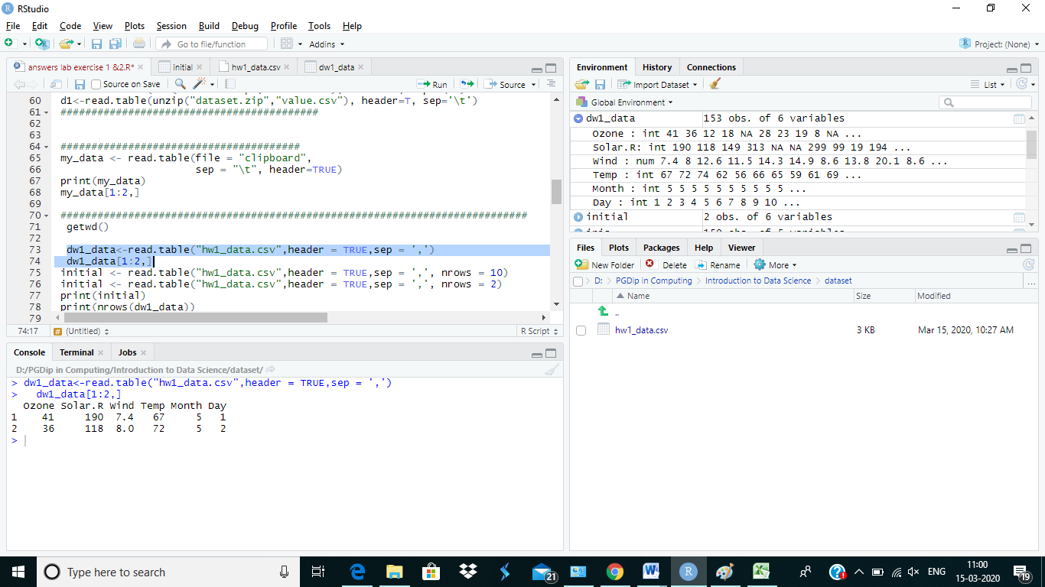

13.c

14. d

15. a

16. a

17. b

18. b

19. d

20. a

21.b

22 . a

23. b

24. d

25. b

26. b

27. a

28. 6.588 ~7

29. e

30. 34